::: USER CENTRIC FRONTEND DEVELOPMENT MILESTONE PROJECT ::: PLAN 15/6/2018 :::

The following outlines the initial plan for the User Centric Frontend development Milestone project based on building a static website for a 1960’s rock band. I’ve chosen ‘Pink Floyd’ because of the wealth of material available and the diverse and interesting imagery used by the band.

# **STRATEGY**

The business and customer objectives will be defined within this section.

## Business Objectives

*Who are our target audience?* Current and potential fans

*What is compelling site visitors to come to the site?* The opportunity to see and hear music from the back catalogue and from the latest releases. Additionally, the opportunity to hire the band to perform at events.

Why is this site different from our competitors? This is the ‘official’ band site therefore new material releases from the band will debut here first. Additionally, allowing fans to hire the band to perform at events and functions.

Baseline business objectives:

* Showcase band materials (music and videos)
* Allow band hiring for events and functions (weddings and Xmas parties).
* Increase fan base
* Increase online presence

## User Objectives

*What content are you wanting on the site?* Band information, tour dates, biographies, music catalogue and videos, additional links and information.

Baseline user needs:

* Access to new releases and music back catalogue
* Videos of the band performing
* Images of the band/members
* Biographies of band members and band history
* Discography
* Links to other relevant sites and social media
* Tour dates and links of where to buy tickets for shows

## Baseline Requirements

Combining the baseline business and user requirements produces the baseline requirements for the project:

Baseline requirements:

* Music and videos
* Band hire
* Image gallery
* Band history and biographies
* Discography
* Social media links
* Tour dates and ticket links

Importance and viability/feasibility assessment

|  |  |  |  |
| --- | --- | --- | --- |
| Opportunity | Importance | Viability/Feasibility | Total |
| Music and videos | 4 | 5 | 9 |
| Band hire | 4 | 5 | 9 |
| Image gallery | 2 | 3 | 5 |
| Band history and biographies | 2 | 4 | 6 |
| Discography | 2 | 2 | 4 |
| Social media links | 4 | 5 | 9 |
| Tour dates and ticket links | 3 | 1 | 4 |
| Summary | 21 | 25 | - |

# **SCOPE**

What will and will not be included in the website will be determined in this section based upon the strategy assessment.

*What will be included in the first release?*

* Music and videos
* Band hire
* Band history and biographies
* Social media links

*What can wait until a website update?*

* Image gallery
* Discography
* Tour dates and ticket links

The initial release development will be broken down into sprint stages (16-24 non-consecutive hours per sprint), these are defined as follows:

|  |  |
| --- | --- |
| Sprint | Tasks |
| 1 | Header development  Footer development and social links |
| 2 | Navigation layout  Home page development |
| 3 | Music page development |
| 4 | Video page development |
| 5 | Band history and biographies page development |
| 6 | Band Hire page development |
| 7 | Final site presentation |

# **STRUCTURE**

The main structure of the project is defined in the following:

* + Bar at top will advertise that the band are available for bookings, this will be linked to the ‘hire us’ webpage
  + Navigation bar (desktop) and navigation-symbol (mobile) located at top each page allows direct access to each page from every other page, this will contain:
    - Home
    - Listen!
    - Watch us live!
    - Find out more about us!
    - Hire us!
  + Footer located at the bottom of each page will contain:
    - Social links: contains band YouTube, Facebook and Twitter links which will open in a new browser window
    - Hire us link which will be linked to the ‘hire us’ webpage
  + The project will contain the following pages, each page will contain the same ‘hire us’ bar; header; and footer:
    - Home: the opening site page
    - Listen: will contain new and previous audio for the user to listen to
    - Watch us live: will contain videos of the band performing
    - Find out more about us: will contain a band overview and member profile
    - Hire us: will contain a calendar of available dates and a submission form to enquire about hiring the band
  + User feedback will be delivered as follows:
    - Link buttons: will change upon hover (desktop) and upon click
    - Mobile navigation icon: will expand on click
    - Social links: will change upon hover (desktop)
    - Audio ‘listen’ buttons will change upon hover (desktop) and upon click
    - Video ‘play’ buttons will change upon hover (desktop) and upon click
    - Videos (Optional): will be opened in a new browser tab (desktop) and potentially full screen for mobile
    - Band and member information image (Optional): will display in a modal box with the image and information upon click and will change upon hover (desktop)
    - Hire us calendar will highlight selected date
    - ‘Submit request’ button on ‘hire us’ page will change upon hover (desktop) and upon click

# **SKELETON**

The preliminary skeletal design for each of the pages defined are shown below:

### HOME PAGE

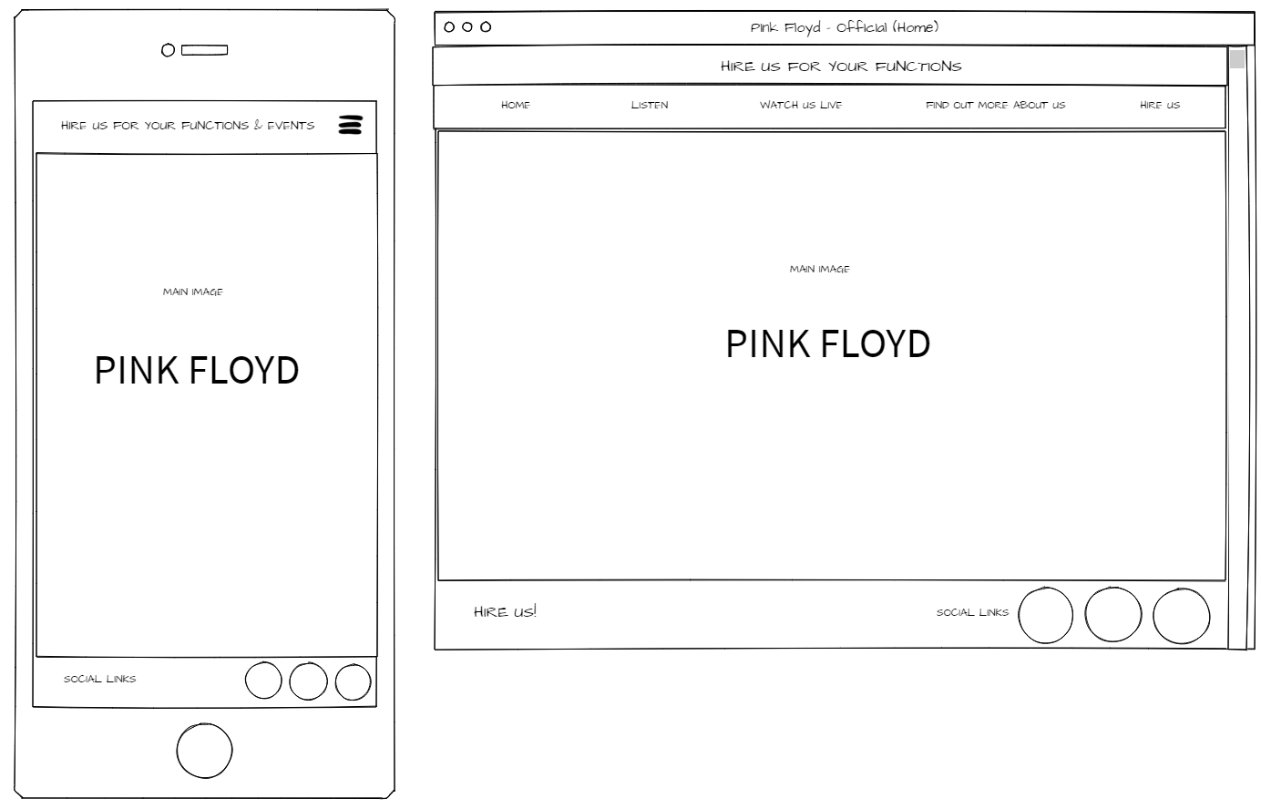

### LISTEN PAGE

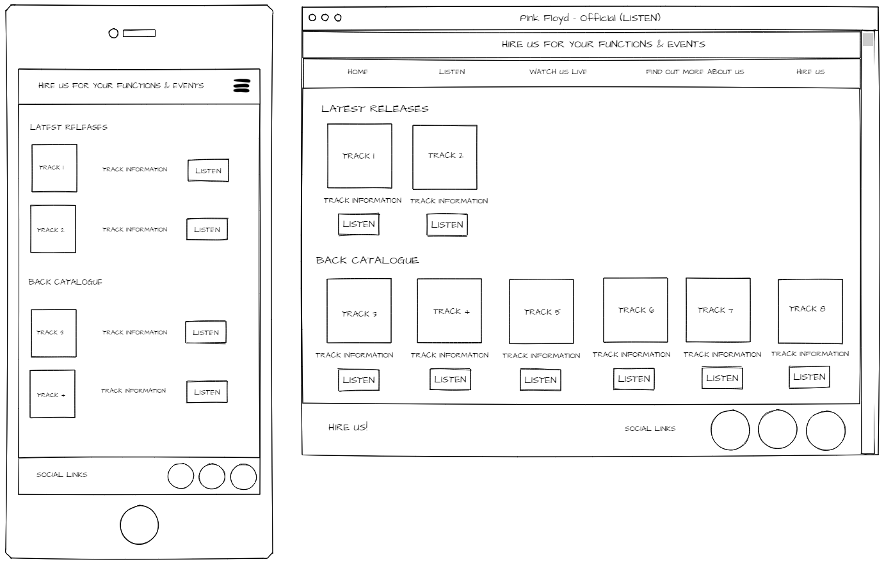

### WATCH US LIVE PAGE

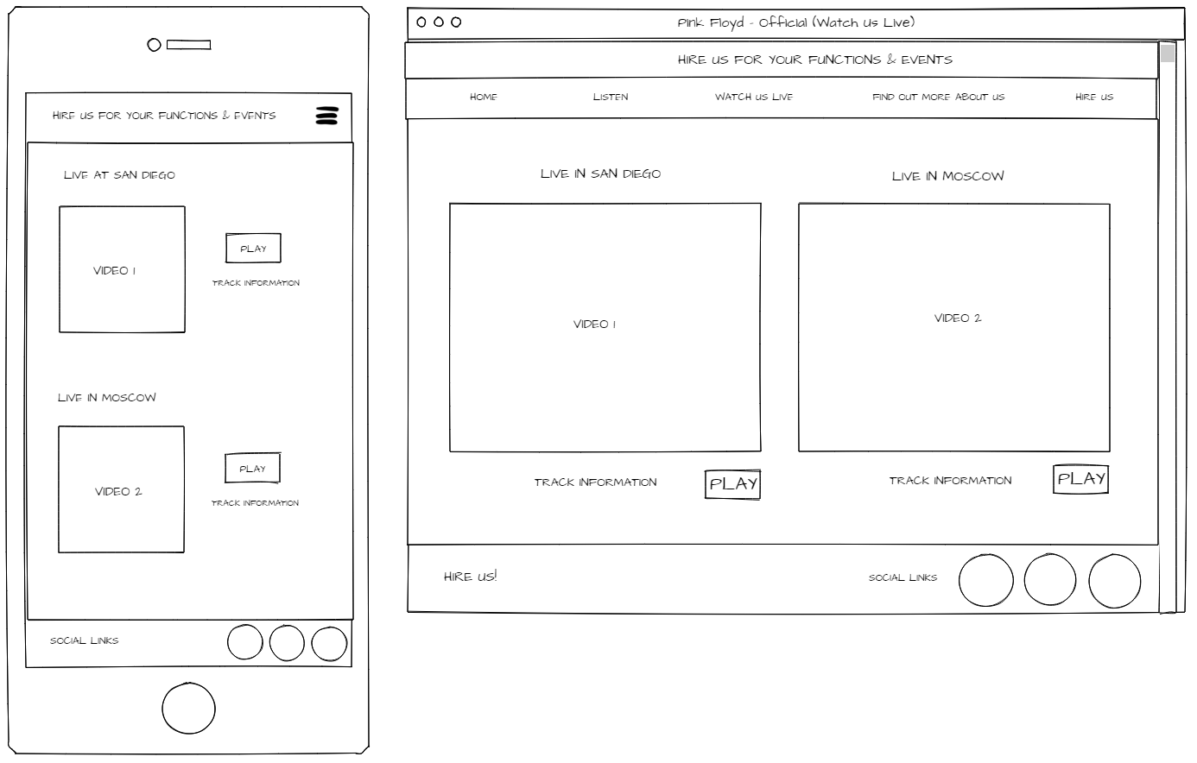

### FIND OUT MORE ABOUT US PAGE

### 

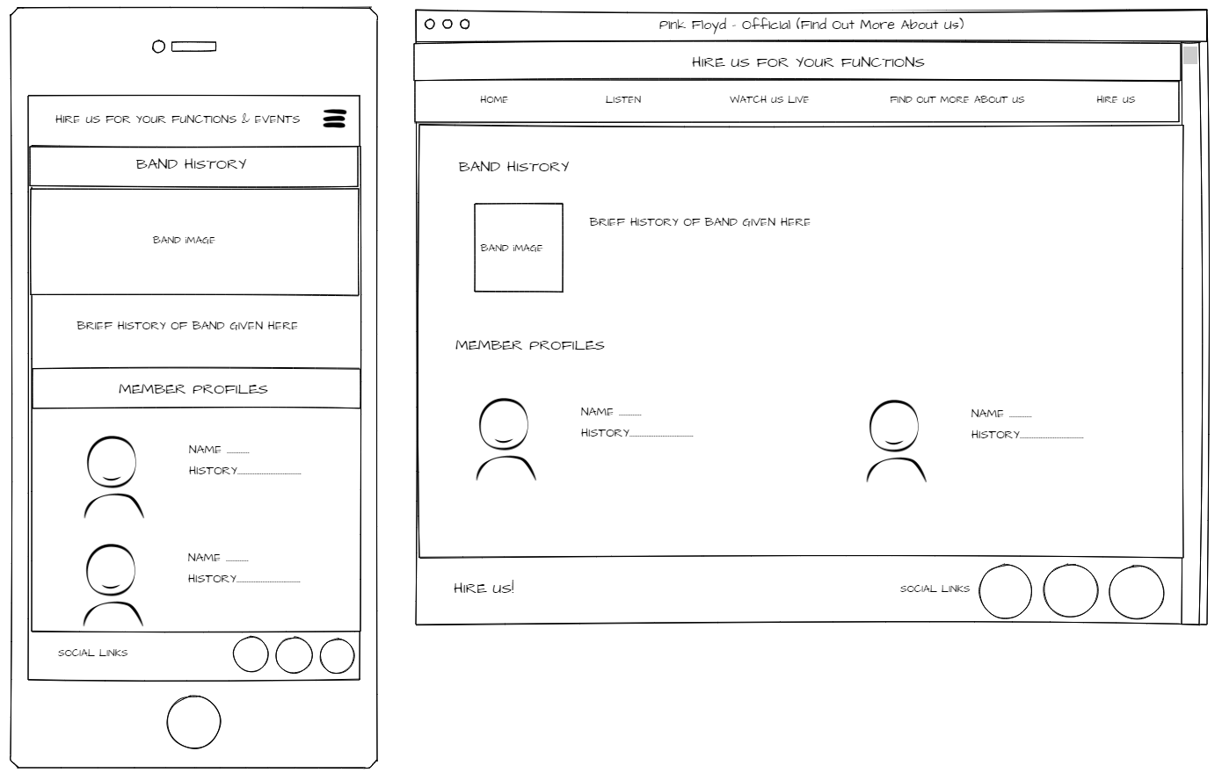

### HIRE US PAGE

